MẠNG MÁY TÍNH Final 2024-2025
Quarter 1
Section 1 (40 marks)
Question 1: Which of the following accurately describes the feature of Cisco Packet Tracer?
A. It is primarily used for malware analysis.
B. It simulates the configuration and behavior of computer networks.
C. It is designed exclusively for advanced programming practice.
D. It serves as a tool for web development.
Question 2: Assume that we have the network 200.20.20.0/24 and we want to divide it into subnets with
30 PCs each subnet. What is the first IP address of the penultimate subnet?
A. 200.20.20.192
B. 200.20.20.193
C. 200.20.20.225
D. 200.20.20.224
Question 3: What does the term OSI stand for?
A. Optical Service Implementation
B. Open Service Internet
C. Open System Interconnection
D. Operating System Interface
Question 4: Which type of NAT allows multiple private IP addresses to be mapped to a group of public IP addresses?
A. Static NAT
B. Dynamic NAT
C. PAT (NAT Overloading)
D. None of the above
Question 5: What is the mistake of the following commands?
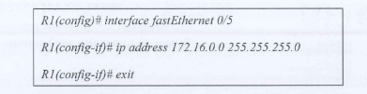
A. Assign wrong subnet mask
B. The interface has not been turned on
C. Assign wrong IP address
D. All of the above
Question 6: What role does the ARP protocol play in TCP/IP model?|
A. Mapping IP addresses to MAC addresses
B. Identifying the network structure
C. Forwarding packets across networks
D. Allocating dynamic IP addresses
Question 7: Which command can show the output as below?
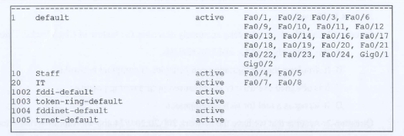
A. show vlan
B. show running-config
C. show vlan-config
D. show startup-config
Question 8: Which type of network is BEST suitable for a computer lab environment?
A. PAN
B. MAN
C. WAN
D. LAN
Question 9: Which network device processes routing information in packets to forward them between networks?
A. Switch
B. Firewall
C. Server
D. Router
Question 10: What does NAT stand for?
A. Network Attenuation Technology
B. Network Automatic Transport
C. Network Address Translation
D. Network Access Terminal
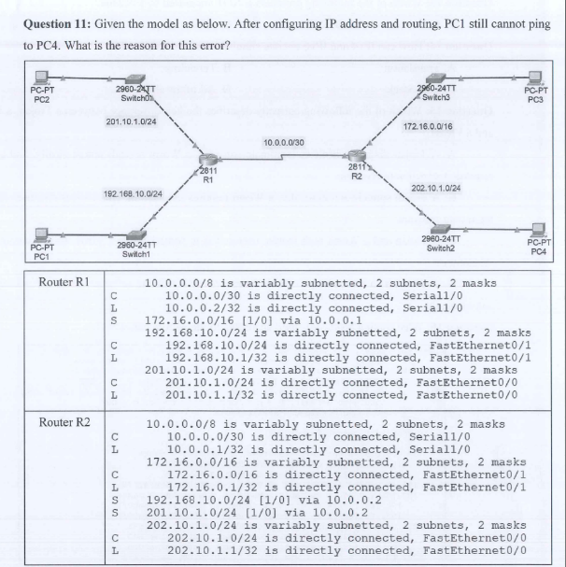
A. Wrong routing configuration on Router RI
B. Wrong routing configuration on Router R2
C. Wrong routing protocols configured on 2 routers
D. Wrong cable connected to 2 routers
Question 12: Given the IP addresss as below 11000000.10101000.00001010.11000000. What is the network address of this IP?
A. 172.168.10.1|
C. 192.168.10.0
B. 172.168.10.0
D. 192.168.10.1
Question 13: Which of the following protocols is NOT supported by FileZilla?
A. FTP
B. FTPS
C. SPTP
D. SMTP
Question 14: How can IPv4 and IPv6 operate simultaneously in a network?
A. Translation
B. Tunneling
C. Dual Stack
D. All of the above
Question 15: Which of the following correctly describes the key difference between a Trojan, a Worm, and a Virus?
requires user action to replicate.
A. A Trojan disguises itself as legitimate software, a Worm spreads automatically, and a Virus requires user action to replicate.
B. A Trojan spreads automatically, a Worm requires user action, and a Virus disguises itself as legitimate software.
C. A Trojan and a Worm both require user action to spread, while a Virus spreads without user intervention.
D. A Virus and a Worm both disguise themselves as legitimate software, while a Trojan spreads automatically.
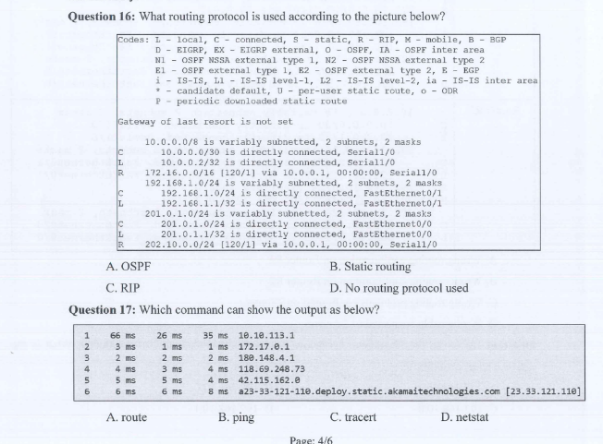
Question 18: Which of the following best highlights the difference between static and dynamic routing?
A. Static routing requires manual route configuration, while dynamic routing automatically updates routing tables using protocols.
B. Static routing performs better in large-scale networks, whereas dynamic routing is more suitable for smaller networks.
C. Dynamic routing enhances security by encrypting routing data, whereas static routing uses unencrypted routing updates.
D. Static routing offers greater scalability by adapting more efficiently to network topology changes compared to dynamic routing.
Question 19: What is the primary purpose of Wireshark?
A. To monitor CPU performance
B. To analyze network traffic and capture packets
C. To perform data encryption on a network
D. To manage file transfers between servers
Question 20: Assume that we have the network 193.172.10.0/24 and we want to divide it into 10 subnets.
What is the last IP address of the ${10}^{th}$ subnet?
A. 193.172.10.158
C. 193.172.10.159
B. 193.172.10.254
D. 193.172.10.255
Section 2 (60 marks)
Question 1: When studying at home, your computer lost connection to the Internet. Based on the OSI model and the knowledge you have learnt, find the possible issues and propose methods to fix them. (10 marks)

Question 2: Divide network 199.99.9.0/24 into 4 subnets using VLSM technique:
LANI: 60 PCs
LAN2: 30 PCs
LAN3: 100 PCs
LAN4: 10 PCs
Calculate and fill in the below table (20 marks)
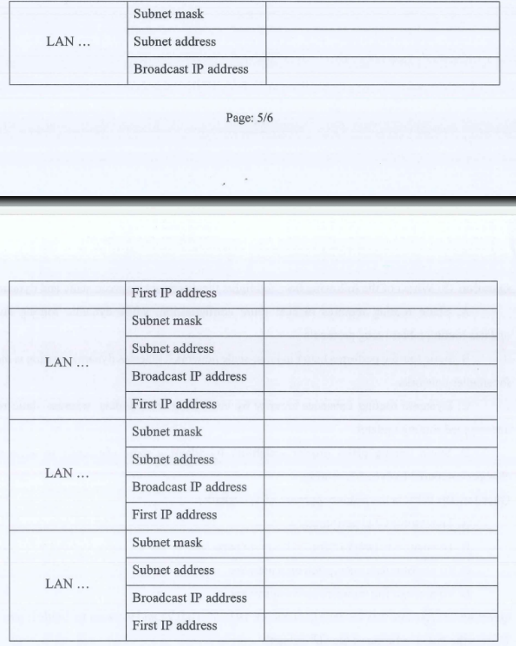
Question 3: You work as a Network Administrator for ABC University. This university has multiple departments. You want to set up a network to connect those departments together. Based on the knowledge you have learned in this course, complete the following requests:
1. Design the network model (10 marks)
2. Configure necessary services. Write down the service names and the configuration commands of each service (20 marks)

